Event Proposal

Prepared for:

Luke Lloyd,

Reading Borough Council.

Prepared by:

Tim Doolan of 10 Days of Prayer.

12 June 2017

Contact:

Tim Doolan.

07928 615 101

10DaysReading@gmail.com

10 Days of Prayer. Reading.

**Introduction** **2**

Overview of Event 3

About the organisers. 3

Management of the Event 4

Safety / Security 4

Team Information 5

Event Control 5

Stewarding 5

Site Management 5

PA 5

Prayer/worship teams. 5

**Welfare Arrangements** **7**

Event Information 7

Refreshments and catering 7

Toilet 7

Forbury Gardens 7

Parking 7

**Forbury Gardens site Plan (not to scale)** **7**

# Introduction

## Overview of Event

In the heyday from the 12th to the 16th Century, Reading Abbey pilgrims travelled afar on their spiritual journey and the Abbey was considered to be one of the uppermost pilgrimage centres of England. The Abbey was dedicated to St.James the Apostle, whose symbol, the scallop shell acts as a sign to welcome pilgrims.

The scallop shell can be seen in Forbury Gardens and is featured on the University of Readings coat of arms. It is the universal sign to welcome pilgrims and is made famous by the pilgrimage route Santiago de Compostela in Spain.

As reconstruction work now begins on the ‘Reading Abbey Revealed’ project, the renovations to the Abbey and the build up to the re-opening to the public in 2018, what a brilliant opportunity to celebrate the place of pilgrimage Reading Abbey once was? Pilgrims will once again be drawn to Reading.

While works are underway to conserve the ruins in this brilliant ‘Reading Abbey Revealed’ project, we propose “10 Days of Prayer” as an opportunity to celebrate and unite Reading and to turn to God in the light of the Abbey’s heritage, as it once was; a place of prayer for pilgrims from all over the world.

To do this a Big top style tent will be set up in Forbury Gardens where the monks once met the public. Everyone, from all walks of life will be welcomed to celebrate and share in this event. There will be an opportunity to meet others , worship, listen to live music or spends some quiet time with God, with a focus on prayer. Part of the 10 Days programme will entail storytelling related to Readings History with the Abbey. Every evening there will be an exciting opportunity for the wider community to hear ordinary people telling extraordinary stories of how they found peace with God on their own adventures as pilgrims.

The first 7 days of the event will meet in Forbury Gardens starting on 20th of September at 5pm and end on the 27th September. The final 3 days will be in a venue TBC, hopefully nearby.

**Entry is free and open to anyone.**

Opt-in collections will be taken towards the costs of the event This is a grassroots event. Any surplus raised through these collections will be used to bless the town of Reading donating to charities and projects within the town. Nobody on the teams will be paid.

## **About the organisers.**

10 Days of Prayer is a team of likeminded Christians with a passion to see Reading and the nation blessed, safe and prosperous . They have come together with the blessing of Bishop Andrew of Reading, Churches Together in Reading and RCN (Reading Christian Network www.readingchristiannetwork.com/ ) who are a network of churches who meet weekly for prayer and to build and sustain relationships together. 10 Days also has the important blessing of the two churches that border Forbury Gardens, St.Lawrence’s (Chris Russell) and St. James (Canon O’Shea).

## Management of the Event

10 Days will manage the event and in conjunction with the tent owners be holders of the appropriate insurance. The main control point for the entire event is based in ‘The bus’ which will be parked onsite at Forbury Gardens. In addition to this effective management of the event is achieved through mobile phone communication and continual walking of the site linking guests and Teams. We will aso have a conversation with the police about having access to the Town safe Radio. Teams will be encouraged to assist and support guests where needed.

## Safety / Security

Security management of the event is vital to ensure the event runs smoothly. All staff will take special care of any changes in the area , people acting in a suspicious manner, packages left or vehicles left in unauthorised areas. In the event of any major incident occurring or having the potential to occur staff will be instructed to contact the Event Manager immediately. The event manager will delegate the incident as appropriate. Two members of security will be onsite throughout the night during the 7 days and although the tent will be available for prayer 24 hours it is expected to have minimal visitors during the night.

A safety announcement will be made before each evening's meeting.

## 

## 

## Team Information

### Event Control

Based at the control point in ‘The Bus’ near the tent, responsibilities include overall event and administration control as follows:

Overall event management General vehicular and visitor management Major incident management Directing of programme and information

Liaison with guests Ensuring safe event delivery. Layout of site Staff management

There will be a red & white tape around the perimeter of the tent where needed.

### Stewarding

On arrival stewards should make themselves familiar with the site and especially with the location of and use of all safety equipment. They will ensure any gangways and all exits are kept clear at all times.

### Site Management

A specific team will be dedicated to be responsible to House keeping and making sure the main tent is set up, safety checked and ready for the event over the 7 days. Litter bins will be provided in and around the tent to help ensure that the gardens are kept tidy. They should also ensure the site is kept clean and tidy, bins are emptied and new liners installed as necessary and that toilets are equipped with toilet paper, soap and clean towels before each event.

### **PA**

The PA staff should arrive in time to make sure that the system is switched on and setup ready for a sound check for any incoming event. They should liaise and meet the requirements of each of those leading the programme and be ready to deliver them in a manner which ensures the safety of those taking part and the members of the public. They are also to ensure that sound levels are kept within acceptable levels remembering excessive levels although enjoyed by the younger can ruin an event for older people. It is vital that the public are kept safe from electrical and cable trip hazards. Attention must be paid to clearly marking any hazards. A generator for the power supply will be checked with RBC to comply with the appropriate sound restrictions.

### Prayer/worship teams.

Worship leaders/teams will ensure that they have discussed any requirements with the PA team before the event as on the days of the event it might be too late to provide any equipment that is required.

### Create

Local Artists may coordinate opportunities for the public to paint and create. They will also be at hand to talk about the Art installations found at various stations within the tent.

### First Aid

Over the 7 days, where possible a registered first aider will be on Forbury Gardens site. They will be responsible to only carry out first aid within their level of training and to call for appropriate assistance for anything beyond this. Royal Berkshire Hospital is the Accident and Emergency department and any walking wounded should be directed accordingly. The first aider will also be expected to make an entry in the First Aid log held at the control point in ‘The bus’ after giving any first aid. They should also immediately after giving any assistance, make the event controller aware of any safety issues highlighted by the incident.

# 

# 

# Welfare Arrangements

## Event Information

The control point at ‘The Bus’ will be the one main point of distribution for event information. Communication via mobile phones will allow early management of any situations that may arise.

## Refreshments and catering

Tea, coffee and hot chocolate will be served in the main tent. (All profits will be put back into the running of the event and any excess will be placed into the [10 Days Fund](https://sites.google.com/view/10daysreading/giving?authuser=0) which will be exclusively used to bless various social projects in Reading).

## Toilet

2 single unit toilets and 1 disabled toilet positioned opposite Forbury Lion north of the tent as seen on map.

## Forbury Gardens

Care will be taken of all gardens and any reparations will be taken out by 10 days in agreement with Forbury Gardens gardener and Luke Lloyd of Reading Council. A special flooring will be used in the tent that is designed to make minimal damage to grass and allow new growth under duration of its use.

## Parking

All visitors will be encouraged to use public transport where possible or pointed towards one of the many possibilities found on the link from our website home page.

# **Forbury Gardens site Plan (not to scale)**

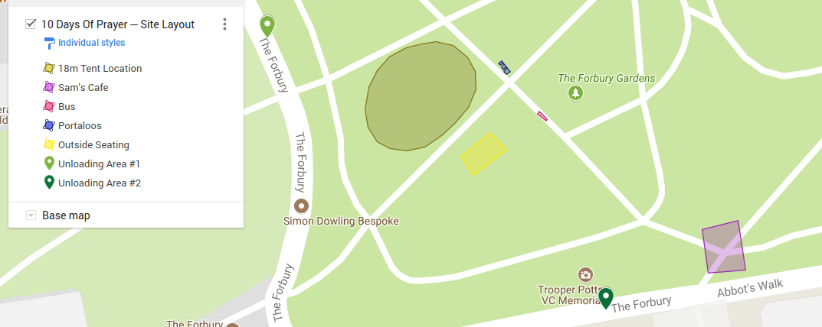

Portaloo